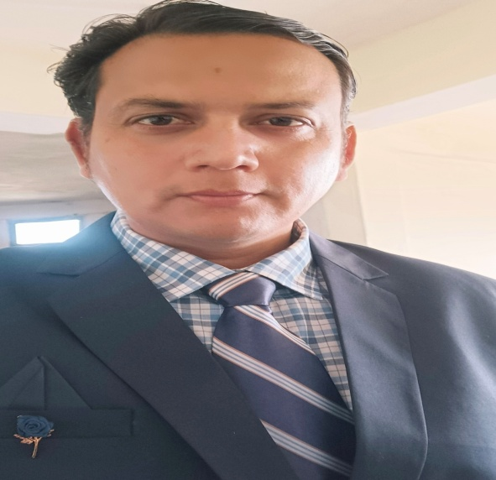

Abhinawa Pokhriyal
Assistant professor in Nimbus School of Education
Area
Primary Area: Education
Secondary Area: Humanities,
Contact: 8979118700
Email: abhipokhriyal1983@gmail.com
Phone: +91-8979118700
Education
• Fellow Program in Political Science (Doctoral Degree), Glocal University
• Master of Education, SDBIT Dehradun (HNBGU)
• Bachelor of Education, DITE (HNBGU)
• Master of Art, Bachelor of Art

Teaching
• History
• ECCE
• Inclusive Education
• Knowledge and Curriculum

Research Area
ICT , Indian History , Indian Polity, Indian Philosophy

Academic Experience
Faculty Member, S.B College of Teacher Education Vikasnagar, Dehradun, April 2012 to October 2016.
Faculty Member, Kukreja Institute of Teacher Education, Dehradun February 2020 to May 2023.
Faculty Member, Nimbus School of Education, July 2023 onwards

Professional Experience
Nimbus School of Education
S.B College of Teacher Education
Kukreja Institute of Teacher Education

Selected Publications

Academic Conferences
Yoga for Holistic Health, Success ,Peace and Introduction to inner Engineering conducted by Isha Foundation Volunteers at Bombay Teachers’ Training College.
Covid-19 : Impact on Food Security and Livelihood through Migration Lens organized by Jhunjhunwala P.G. College Ayodhya
Building Economy and Business Resillence Agility and Sustainability in the Past COVID-19 Era Conducted by Globsyn Business School.
Combining Creative Thinking with Technology Essential for the VUCA World We Now Live in Conducted by ADMAA Series AMITY UNIVERSITY.

FDP attended

